

Questions and Answers

OSHA Express

Contents
I cannot locate my Inspection on the Federal OSHA Web site. Where is it? 2
I have grouped citations in my inspection but every time I make a change it looks like it “worked” but the Violation screen print out is not correct. The OE will not make the correct changes for me. What do I do? 3
Please Help! I cannot get the OE to let me load the Severity and Probability in the Violation Penalty Calculation worksheet. It is not working correctly! 4
I have entered two (2) OSHA1s for the same inspection. What do I do? 5
I have accepted a match for the Inspection company name but I needed to make one small change. Now the other inspection is changed and incorrect. What do I do? 5
Why can’t I scan in my stuff on the Scanners in the offices? 5
What do we do with our Photos for a file? 6
How will we know if there are Photo CD/DVD or Video with a file? 6
Where do I Import pictures into the OE for Violations? 6

I cannot locate my Inspection on the Federal OSHA Web site. Where is it?
Activity Key Interface

Every Inspection has an identifying number (Activity Key) that is transferred to the OIS. It is the 6 digit number located beside our NC number. That number will always be the Inspection number for NC in the OIS. You will also use that number in the OIS and the Federal OSHA Web Site to locate a specific inspection to see what transferred over and if you need to make any changes on your side.
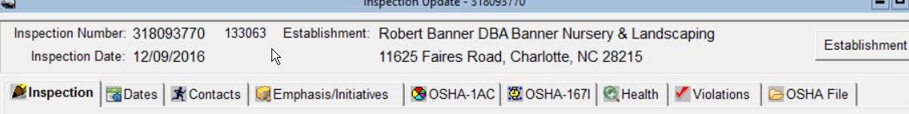
To locate you will use the below Establishment Search on the Federal OSHA Web site.
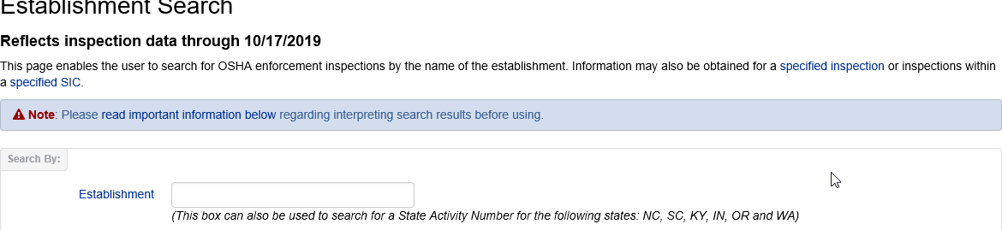

The Citation package also has information for the Employer on locating their inspection on the Federal OSHA Website on Page 1 and Page 3.

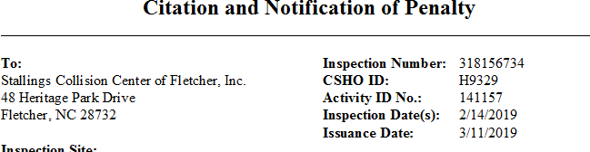

I have grouped citations in my inspection but every time I make a change it looks like it “worked” but the Violation screen print out is not correct. The OE will not make the correct changes for me. What do I do?

Violations that are grouped are “joined”, they must be separated before any changes can be made. This means that the grouping number assigned to the violation must be take out, modifications saved and then make your changes.
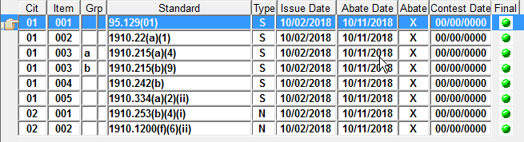

Citation “01 003 a” would become “01 003” during the changes. Once completed, you would reassign the grouping number.
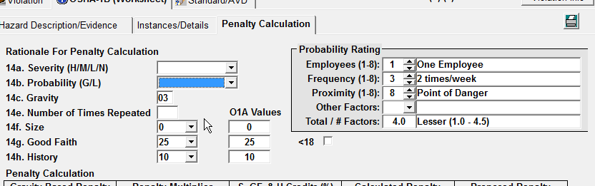

If there are changes to the Penalty Calculations, remember to “right click” out, clear the 14a Severity and 14b Probability fields, and then use the appropriate coding in the drop down boxes for each to reset. *If you do not right click out the Severity/Probability field, the changes will not show on the Violation screen and print out*

Please Help! I cannot get the OE to let me load the Severity and Probability in the Violation Penalty Calculation worksheet. It is not working correctly!

When the Severity and Probability will not load in the Penalty worksheet, it will be due to the fact that you have an Administrative Penalty that you are working on. Administrative Penalties are preset and preloaded into the OE. You cannot make changes to these in the 14a and 14b Rationale For Penalty Calculation section.
Administrative Penalty Interface FOM Chapter VI- Penalties – 13. Violation of Regulatory Requirements
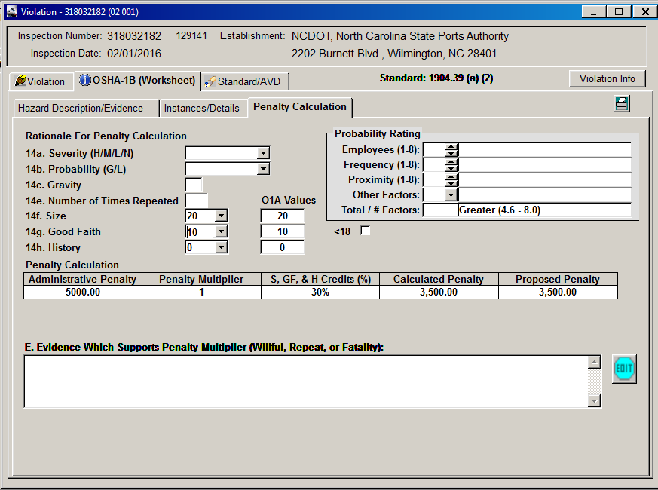

There are 3 individual standards that will have an Option 1 or Option 2 associated with them in the table. You can only have one standard and one penalty per standard, so Option 1 with the associated standard and penalty is the one that will pull to the OSHA 1B Worksheet when selected. Option 2 allows you to do an overide.

*See also* FOM Chapter VI - Penalties – 13. Violation of Regulatory Requirements – C. Migrant Housing Act Violations

There are 3 standards that will have and Option 2 :
1904.39(a)(1) Option 1 | $5,000.00 | Failure to report fatality 8 hrs.
1904.39(a)(1) Option 2 | $7,000.00 | Failure to report fatality BC Option
1904.39(a)(2) Option 1 | $5,000.00 | Failure to report hospitalization 24 hrs  Eye loss or amputation of more than 1 digit
1904.39(a)(2) Option 2 | $2,500.00 | Failure to report other hospitalizations
NCGS 95-226(a) Option 1 | $5,000.00 | Failure to register migrant housing | No History reduction
NCGS 95-226(a) Option 2 | $1,000.00 | Failure to register migrant housing 45 days  prior to occupancy | No History reduction

I have entered two (2) OSHA1s for the same inspection. What do I do?

Contact your OE Administrator to have one of them deleted.

I have accepted a match for the Inspection company name but I needed to make one small change. Now the other inspection is changed and incorrect. What do I do?

It is never a good idea to accept a match on the employer name and address. If you know with 100% certainty that nothing will change, then YES. If not, NO. If only the OSHA1 is completed and saved Final, the new inspection will be deleted after the changes have been corrected. If you already have the OSHA1, Dates, Narrative and other items in the file, your System Administrator will have to contact ACS to fix the issue.

Why can’t I scan in my stuff on the Scanners in the offices?

Each scanner is dedicated to a specific office and administrative staff only. They have been installed to work with the OE in the paperless environment. The administrative staff use these scanners on a daily basis to help speed the processes they must use each day. The Scanner module is set to work with administrative staff only since they are the daily processers. Each office is equipped with BizHubs that have the capability of reducing a copy to a small PDF and changing a picture copy to a JPG if needed. The Scanners are not set up to do this.

All field offices have BizHubs with the capability of converting mail copies, emails, PDFs, etc. to JPG format. When scanning in on the Bizhub, remember to choose PDF then look for option of JPG.
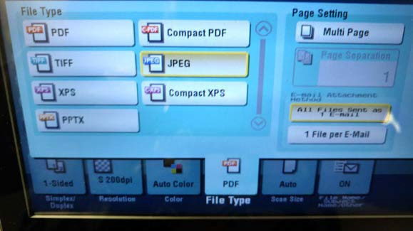

What do we do with our Photos for a file?

CD/DVD Photos and Video will be placed in the Medical Records Cabinet in each field office. Once the file has been processed (Citation Package or No inspection) the Photos will be given to the Administrative Scanner staff to place in the cabinet. The 6 x 9 Manilla envelope with the peel and stick label, to be completed by the CSHO, will hold the CD/DVD/Video Photo records and will be filed by Year and Establishment name.

How will we know if there are Photo CD/DVD or Video with a file?

The Evidence Sheet will be used for this process and scanned into the OE Documents section. The Evidence Sheet will be located on the One Stop Shop under FORMS.

Where do I Import pictures into the OE for Violations?

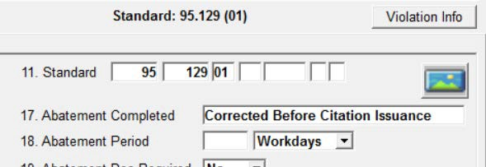Effective October 1st, 2019, use the Photo ICON on the Violation screen to enter your photos associated with the specific violations. Photos for violations should have no more than 3 for each specific violation.

