Fatality Check List- Serious Fatal Log
Supervisor – Receives the Notification from the Complaint Desk, if applicable will assign the CSHO.
Supervisor – Queues to the CSHO the Fatality Assignment and makes the updates to the Serious Fatal Log
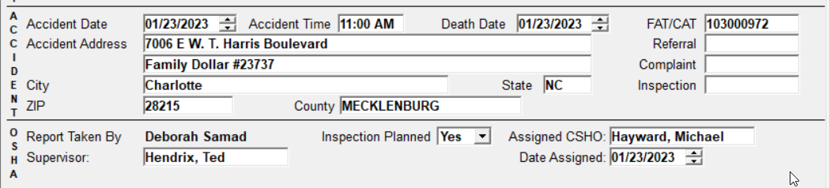

CSHO – Once the fatality has been assigned and opened the csho will input the Inspection number on the Serious Fatal Log
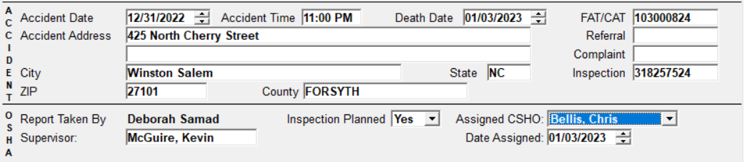

Change to the Inspection: Inspection has changed from Partial to No Inspection
Supervisor and/or CSHO will go to the Serious Fatal log and right click out all information related to the Inspection.
