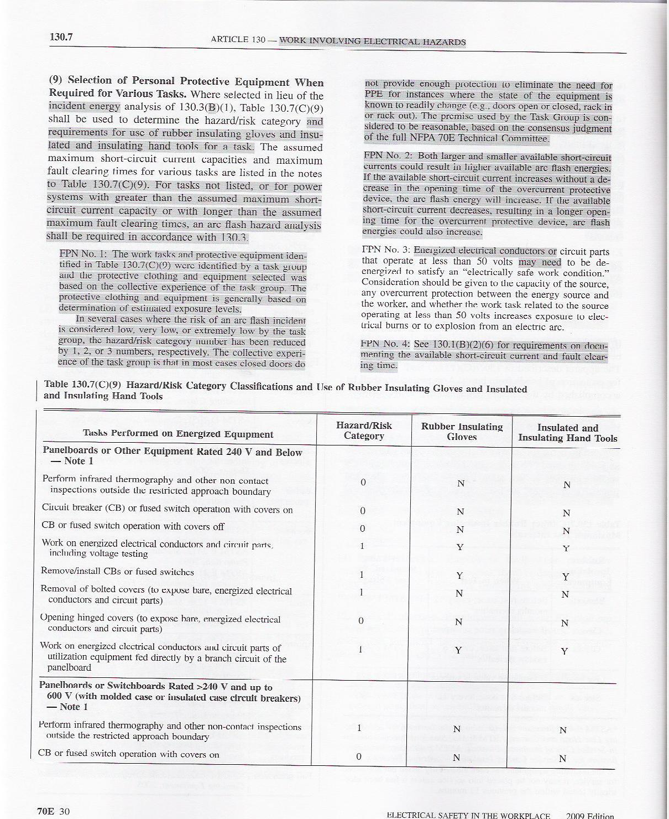
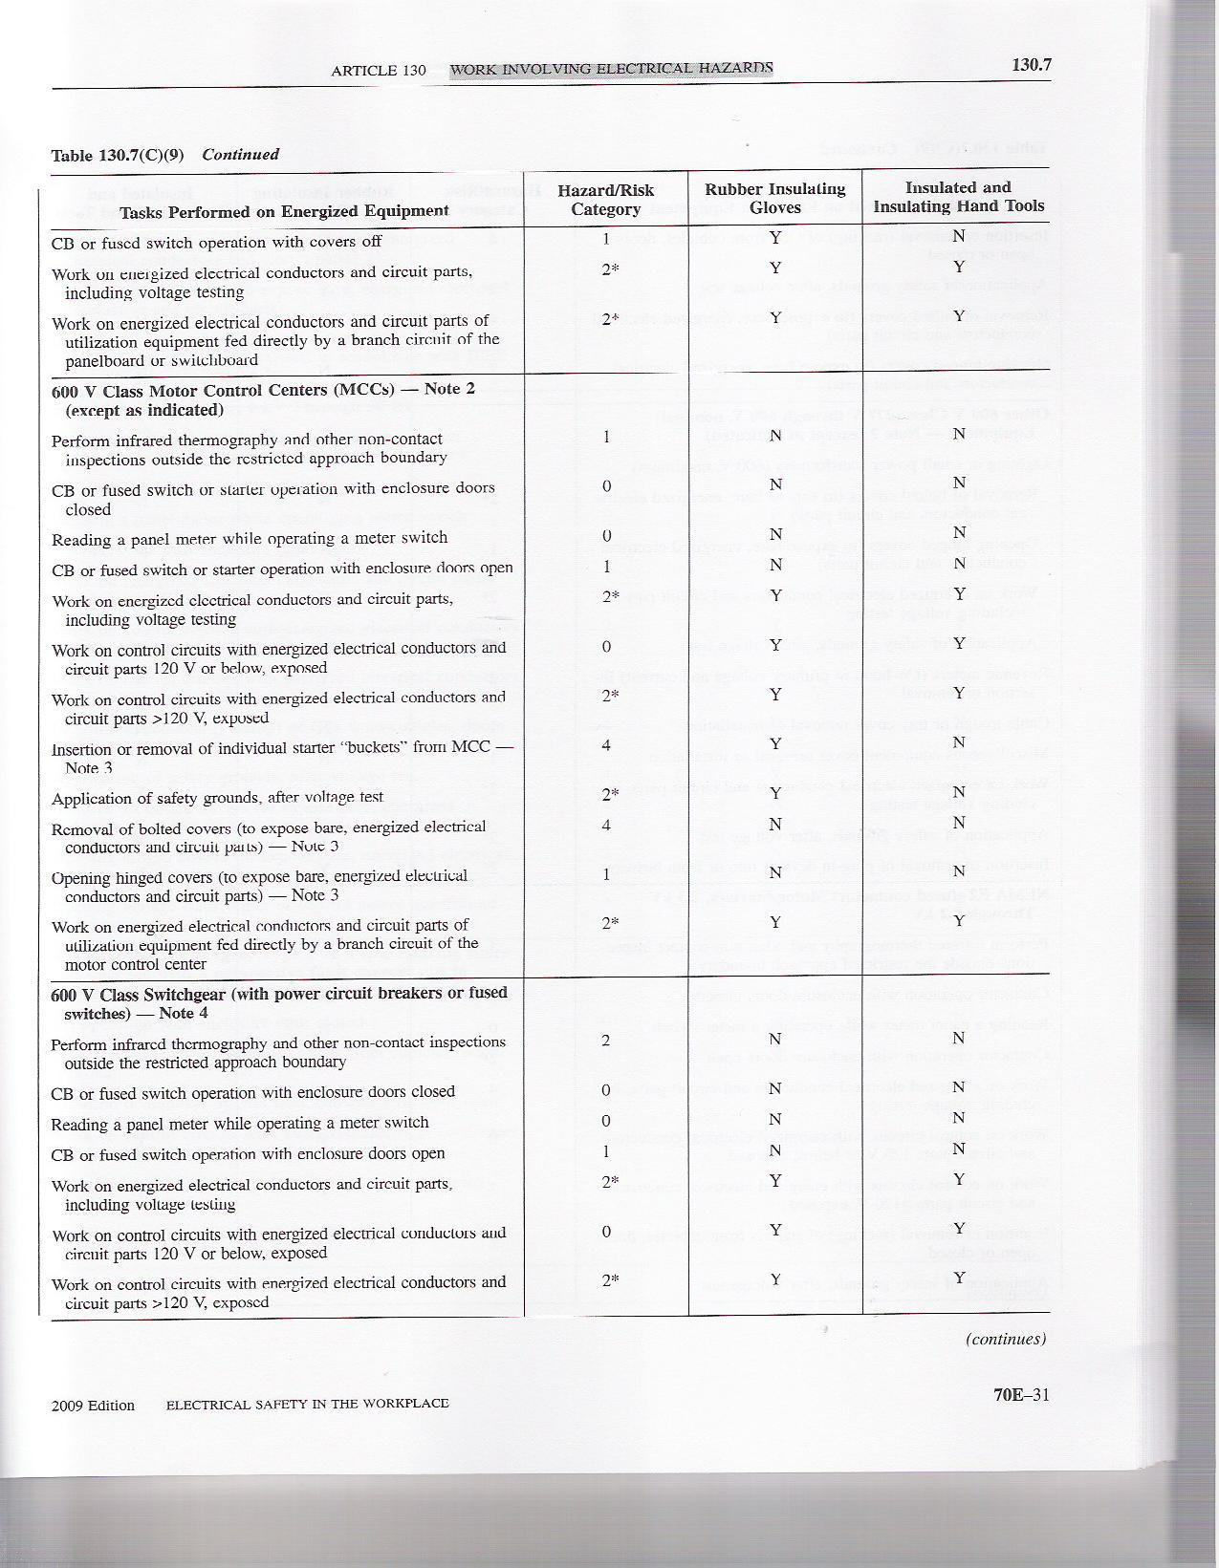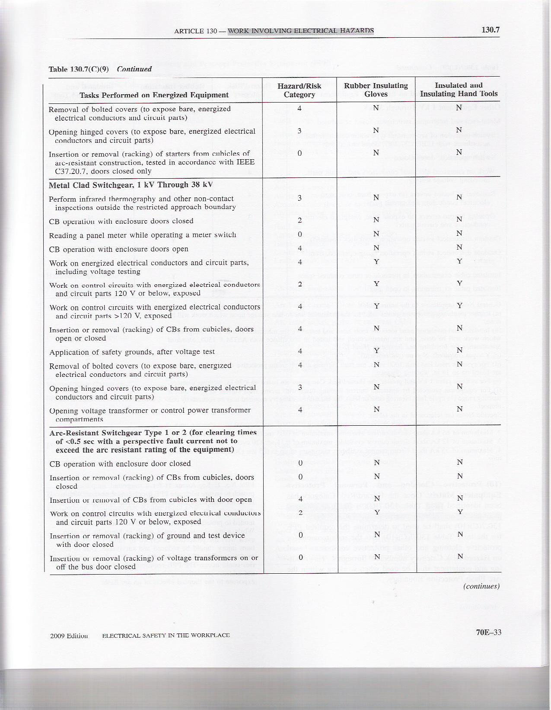
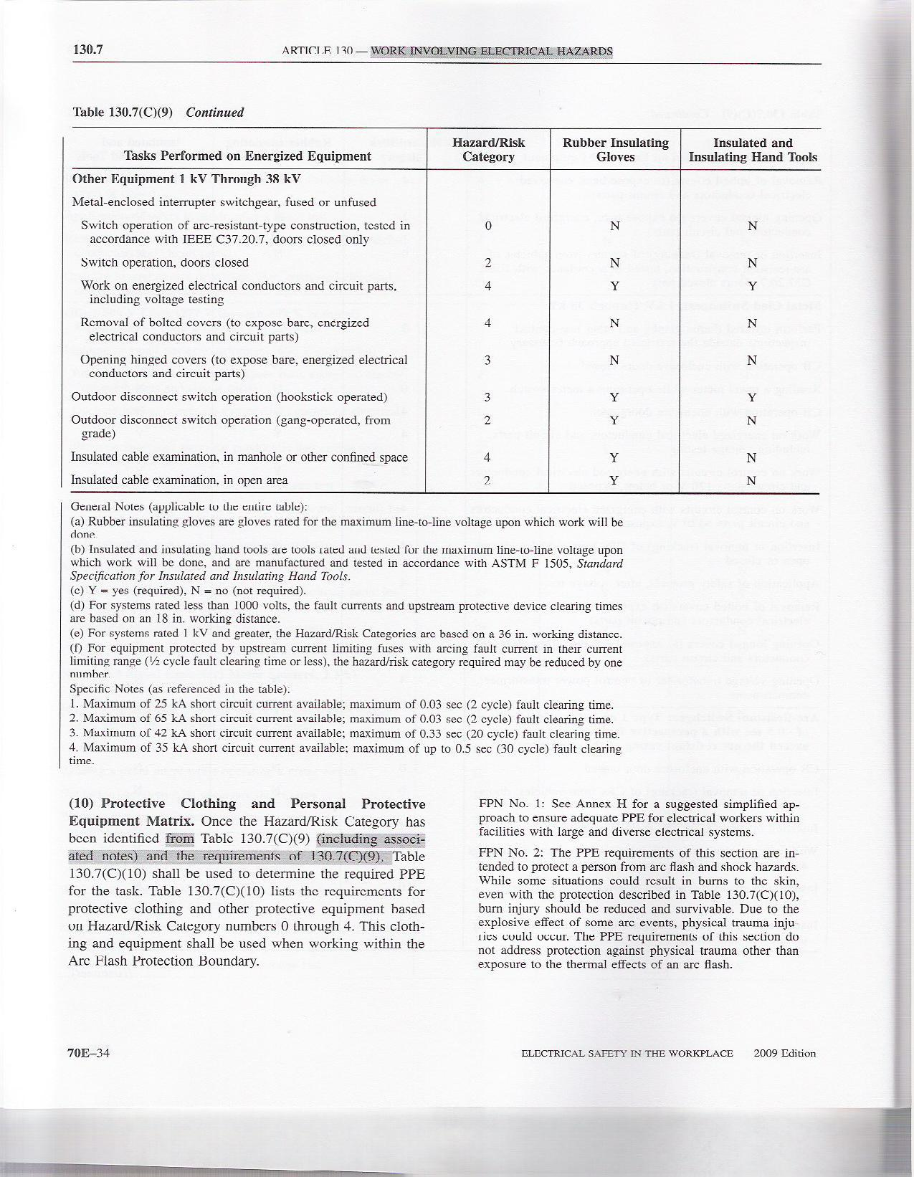
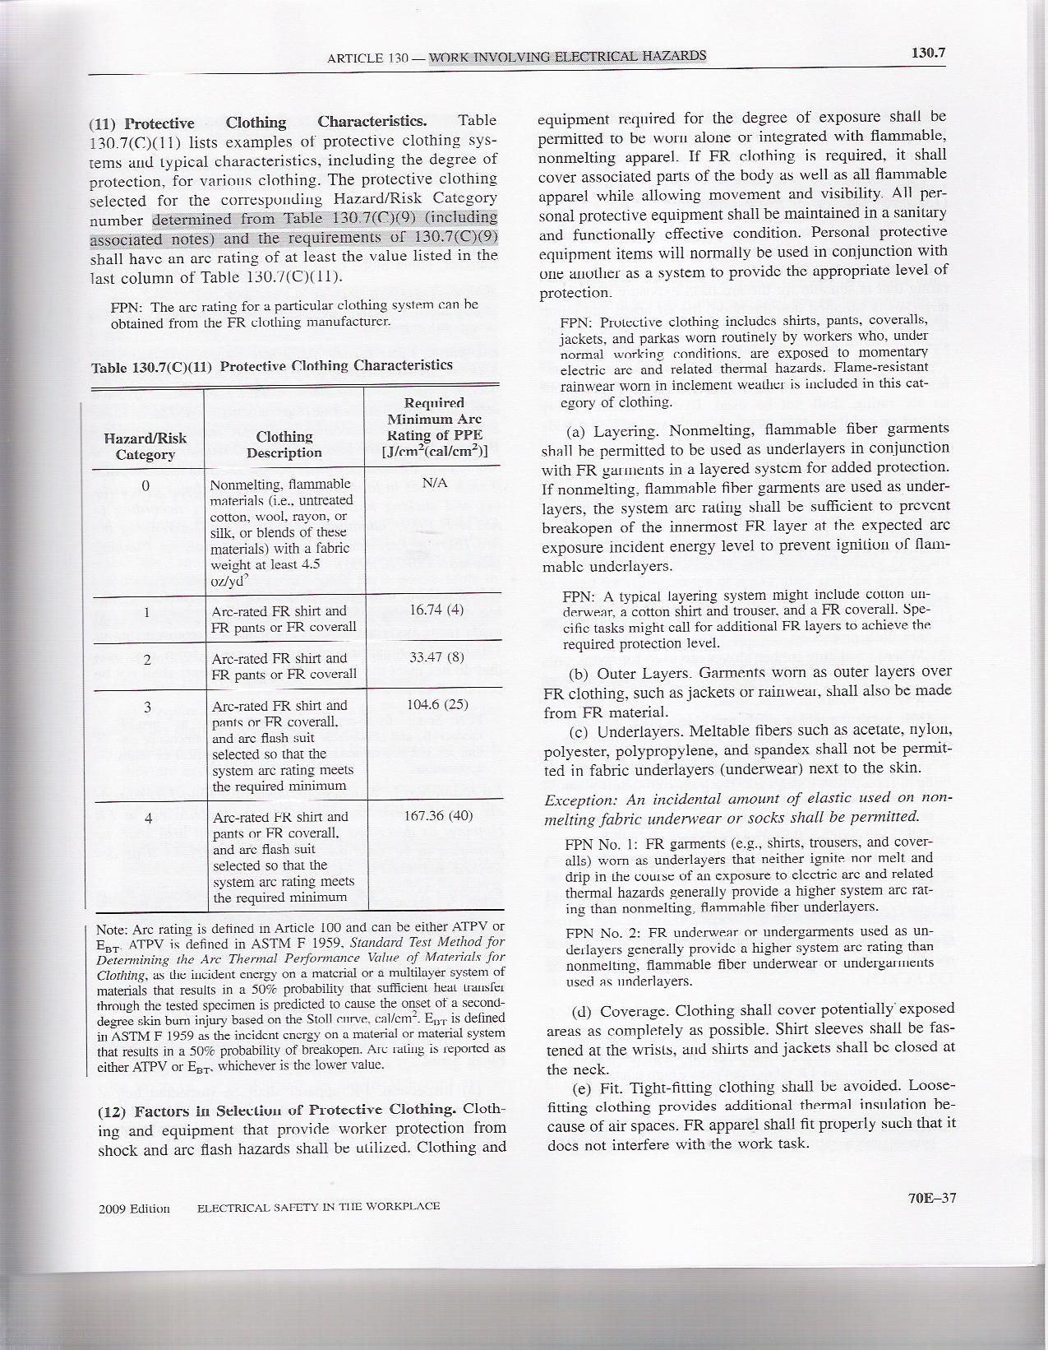
Hazard/ Risk Category | Clothing Description (Typical number of clothing layers is given in parentheses) | Required Minimum Arc Rating of PPE (cal/cm²)
0 | Non-melting, flammable materials (i.e., untreated cotton, wool, rayon, or silk, or blends of these materials) with a fabric weight of at least 4.5 oz/yd² (1) | N/A
1 | FR shirt and FR pants or FR coverall (1) | 4
2 | Cotton underwear – conventional short sleeve and brief/shorts, plus FR shirt and FR pants (1 or 2) | 8
3 | Cotton underwear plus FR shirt and FR pants plus FR coverall, or cotton underwear plus two FR coveralls (2 or 3) | 25
4 | Cotton underwear plus FR shirt and FR pants plus multilayer flash suit (3 or more) | 40

